Thi Nguyen and Daniel Kostecki

Group 12

Web Programming Final Project

Instructions:

Program may be run locally by downloading the files on GitHub or more easily using the web program running on Heroku at URL <https://cs416-final-project.herokuapp.com/>. When you reach the homepage, you can view the items along with their names, descriptions, and prices.

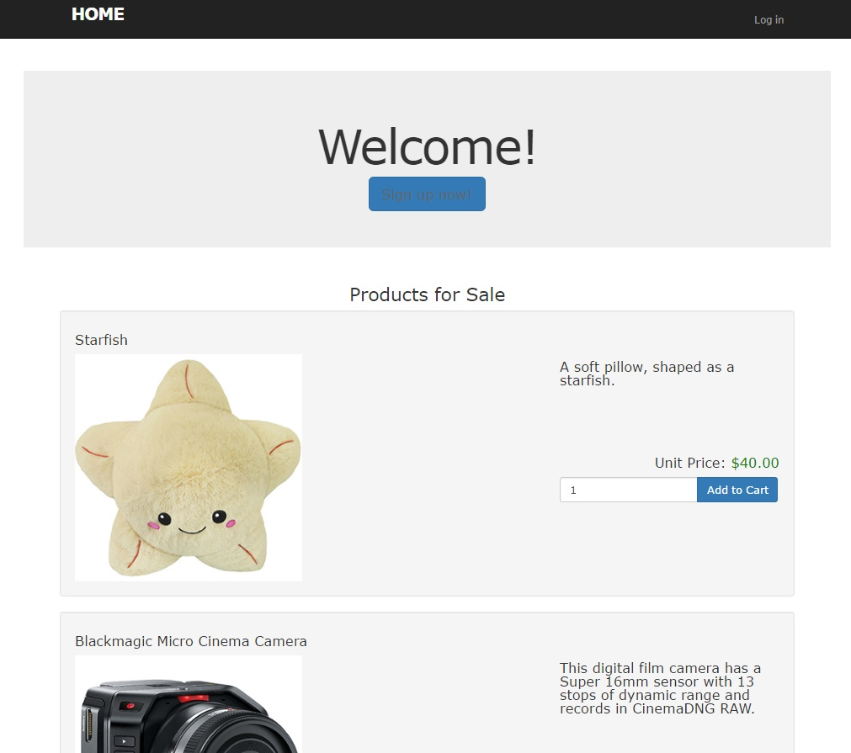

If you click on “add to cart” but are not signed in, then you will be directed to a page to sign in.

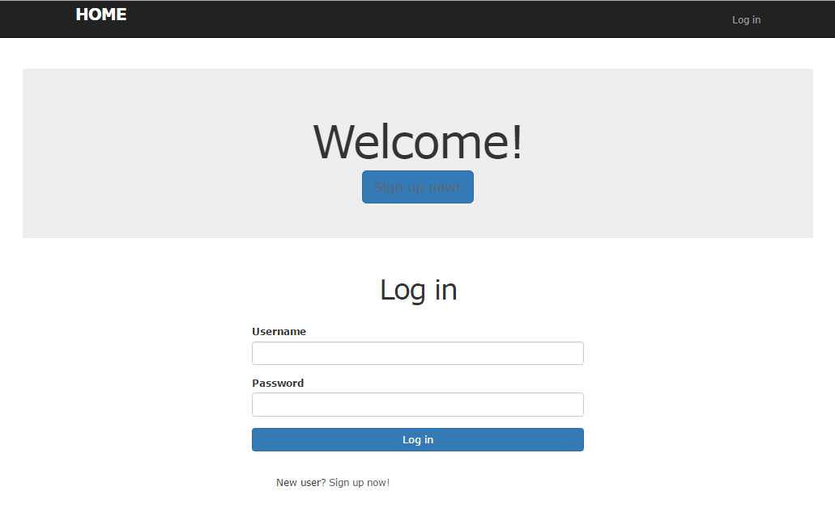

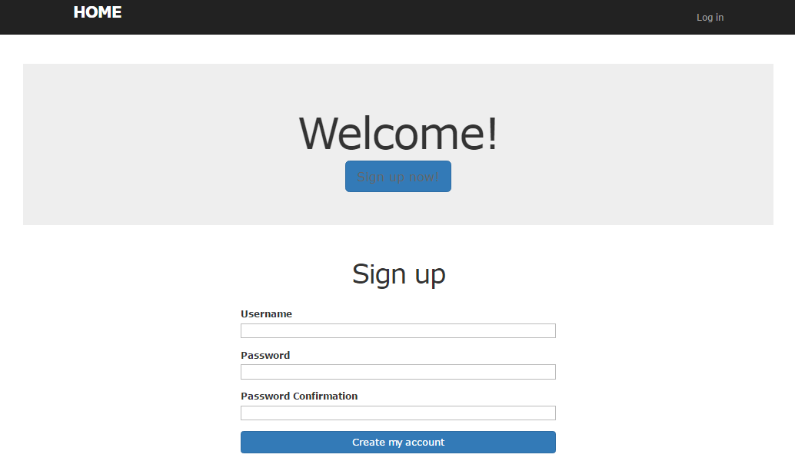If you are signed in it will add the item to your cart (complex flow). If you do not have an account, you can click “sign up now” (creation and validation).

From there you are redirected to the homepage where you may add items to your cart (AJAX in cart showing items and price and updates).



If you click on the shopping cart you can view your items and your total, where you can delete items.

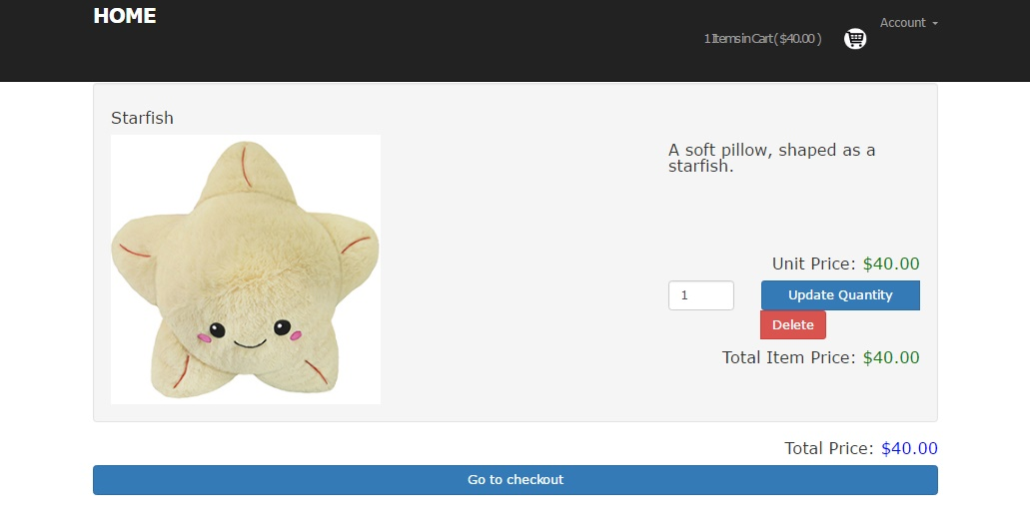

Table relationships include multiple products per cart. Bootstrap was used to make the page responsive and to have a unified look and feel.